BBQ Reservation

User Interface for the BBQ Telegram Bot

TEAM 2

Abdoulie Kassama

Danil Afanasev

Konstantin Britikov

Talgat **Khairov**

# Table of Contents

Table of Contents 2

Version Information 2

GitHub Repository……………………………………………......................2

Introduction 3

Background……………………………………………………………….……….….3

Scope…………………………………………………………………………………….3

About this document 3

References 3

Graphic treatment 4

Abbreviations and acronyms………………………………………………….4

Structure and Navigation 5

Navigation 6

User Interfaces 7

1 Create Reservation 7

Description 8

Navigation 8

Message Box 9

Elements 9

2 Cancel Reservation 9

Description 10

Navigation 10

Elements 11

Message Box 11

Chat Message 11

3 View Reservation 11

Description 12

Navigation 12

Elements 13

Message Box 13

Chat Message 13

Chat Texts 13

4 Send Message (Bot) 13

Description 14

Navigation 14

Elements 15

Chat Messages 15

## 

## Version Information

Version 1.0 R.E Team 2 Innopolis University October 14 2019

Git-Hub Repository: [>>](https://github.com/gbrigens/BBQReserver/)

# Introduction

This document describes the User Interface for the BBQ Reservation Application.

**Background**

The BBQ Reservation application is meant to be a replacement for the current system which is just a google form that allows anyone to make any change to the spread sheet. It requires you to check for the times and other details to avoid conflicts. This new application is meant to make to booking much easier and organized using a telegram bot. User would be able to book, edit or check for slots through the telegram bot. The bot does all the checking and validation on the spreadsheet and sends the user responses.

**Scope**

This document is the User Interface Design Document for the BBQ Reservation system. The purpose of this document is to present the design approach for the graphical interface of the BBQ system telegram bot application. The main intended audience of this document is for the system designers, system developers and even users. The document is intended to provide all the participants and stakeholders demonstration of the application view and some technical details of the system design to be followed during the development of the BBQ application. The document may need to be updated later to incorporate further possible changes during development.

## About this document

The remainder of this document is divided into the following sections:

* *Structure and Navigation* describes the structure of the telegram bot, and the ways in which users can interact with it.
* *Screen Descriptions,* it comprises of the main part of the document, contains a detailed description of each screen and its component parts.
* The Appendix contains a list of all accompanying files.

## References

Refer also to the following documents:

*Use Cases*, GitHub [link>>](https://github.com/gbrigens/BBQReserver/blob/master/BBQ%20Use%20Cases.pptx).

*Activity Diagrams*, GitHub [link>>](https://github.com/gbrigens/BBQReserver/blob/master/Docs/Activity%20diagrams.docx).

*Class Diagrams*, GitHub [link >>](https://github.com/gbrigens/BBQReserver/blob/master/Docs/BBQReserver%20Class%20Diagram(1).png).

## Graphic treatment

The screen representations in this document use telegram UI images and other visual images but should be considered as indicative of the elements to be contained within pages; rather than a representation of their appearance.

## Abbreviations and acronyms

A list of the principal abbreviations, keywords and acronyms used in the document is provided here for a better understanding of this document.

|  |  |
| --- | --- |
| **Abbreviation** | **Definition** |
| BBQ | Barbeque |
| Bot | a software application that runs automated tasks over the Internet |
| HTTP | HHypertext Transfer Protocol |
| API | An application programming interface |
| Telegram | A cloud-based instant messaging and voice over IP service |

# 

# Structure and Navigation

The overall structure of the application is relatively simple, as shown in the following diagram.

Note: Numbers in the diagram provides a cross-reference to individual screens described in this document.

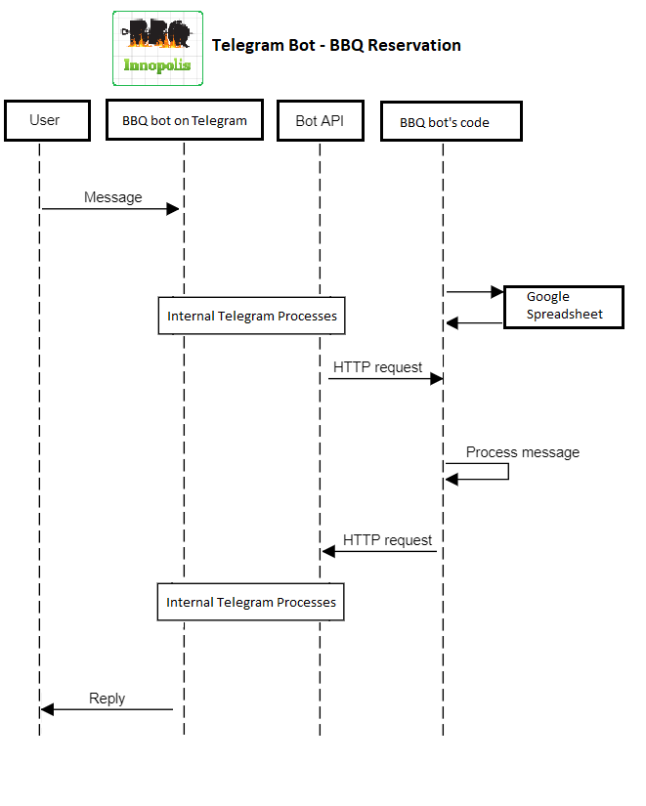

The main components to the systems, consisting of the user, telegram bot, bot’s code, and the google spreadsheet.

The structure is further broken down in the following diagrams.

## User Interfaces

This section contains the user interface of the BBQ telegram application, the functionalities are grouped visually and logically.

### Main Menu

The starting point.

Reserve function allows to see available slots, reserve a time slot or add yourself to the waiting list of a taken time slot.

View reservation function allows to see current reservations, booked by a telegram user.

Cancel is for cancelling user’s reservations.

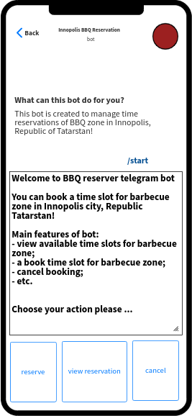

### Create Reservation

This interface where the primary actor (user) creates a new reservation.

First, the user selects a day.

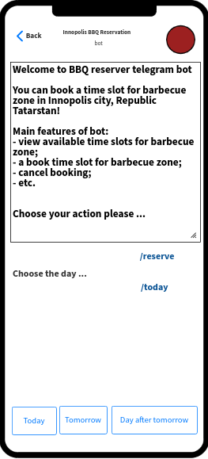

Second, the user selects a time slot.

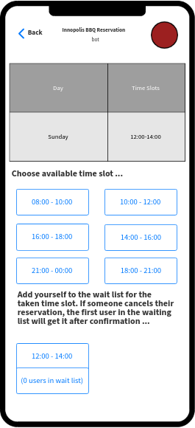

|  |  |
| --- | --- |
| **Purpose/Description** | Reserve a time slot |
| Navigation and User Interaction | 1. Choose day 2. Choose time slot for reservation or waiting list |

# Elements

The following is a list of all elements in this screen.

Message Box

|  |  |
| --- | --- |
| Type: | Textbox |
| Label: | ‘Message’ |
| Content: | Input for typing message or request to telegram bot. |
| Default: | Empty |
| Behaviour: | Standard. |
| Validation: | Refer to the bot by typing @ before the bot name. |
| Comment: | None. |

Chat Messages

|  |  |
| --- | --- |
| Type: | Text |
| Label: | Text Message |
| Content: | Message conversation between user and bot. |
| Default: | Empty |
| Behaviour: | Standard. |
| Validation: | Initiate conversation to the bot by typing @bot name before starting chat. |
| Comment: | None. |

Chat Table

|  |  |
| --- | --- |
| Type: | Table |
| Label: | Days, Time Slots |
| Content: | Reservations from the google spreadsheet. |
| Default: | Empty table |
| Behaviour: | Standard table. |

### Cancel Reservation

This interface is where the user can cancel the reservation.

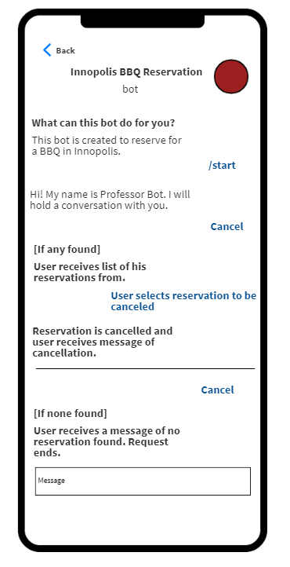

|  |  |
| --- | --- |
| **Purpose/Description** | The user can send a request to the bot to cancel his/her existing reservation. |
| Navigation and User Interaction | The user sends the request for cancellation by clicking the *Cancel* button, if any found, user would receive a list to select from. Then bot deletes the reservation. |

# Elements

The following is a list of all elements in this screen.

### Message Box

|  |  |
| --- | --- |
| Type: | Textbox |
| Label: | ‘Message’ |
| Content: | Input for typing message or request to telegram bot. |
| Default: | Empty |
| Behaviour: | Standard. |
| Validation: | Refer to the bot by typing @ before the bot name.. |
| Comment: | None. |

### Chat Messages

|  |  |
| --- | --- |
| Type: | Text |
| Label: | None |
| Content: | Message conversation between user and bot. |
| Default: | Empty |
| Behaviour: | Standard. |
| Validation: | Initiate conversation to the bot by typing @bot name before starting chat. |
| Comment: | None. |

### Chat Table

|  |  |
| --- | --- |
| Type: | Table |
| Label: | Days, Time Slots |
| Content: | Reservations from the google spreadsheet. |
| Default: | Empty table |
| Behaviour: | Standard table. |

### View Reservation

This interface is where the user can view his/her reservations in the google spreadsheet.

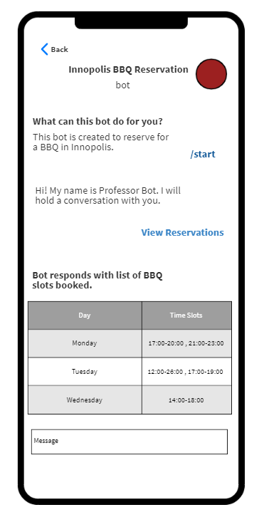

|  |  |
| --- | --- |
| **Purpose/Description** | User can send request to view reservations. |
| Navigation and User Interaction | By clicking *View Reservation* button in the main menu, the user receives the list of his/her reservations |

# Elements

The following is a list of all elements in this screen.

### Message Box

|  |  |
| --- | --- |
| Type: | Textbox |
| Label: | ‘Message’ |
| Content: | Input for typing message or request to telegram bot. |
| Default: | Empty |
| Behaviour: | Standard. |
| Validation: | Refer to the bot by typing @ before the bot name. |
| Comment: | None. |

### Chat Messages

|  |  |
| --- | --- |
| Type: | Text |
| Label: | Text Message |
| Content: | Message conversation between user and bot. |
| Default: | Empty |
| Behaviour: | Standard. |
| Validation: | Initiate conversation to the bot by typing @bot name before starting chat. |
| Comment: | None. |

### Chat Table

|  |  |
| --- | --- |
| Type: | Table |
| Label: | Date, Time Slots |
| Content: | Reservations from the google spreadsheet. |
| Default: | Empty table |
| Behaviour: | Standard table. |
| Comment: | The information might be in the form of text as well. |

### Send message (abstract)

This interface is when the bot makes an action in the spreadsheet and sends response to user.

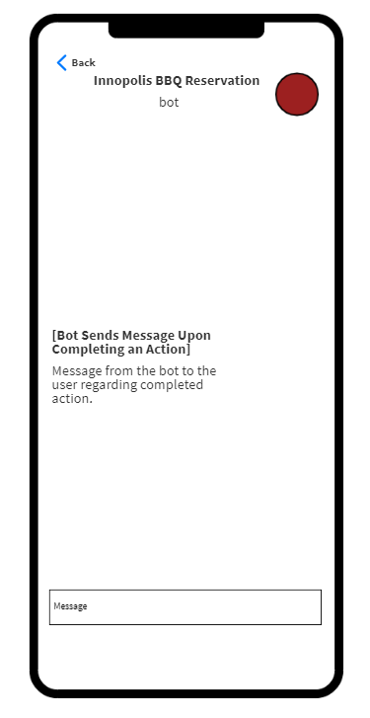

|  |  |
| --- | --- |
| **Purpose/Description** | When the bot sends a message to the user upon performing an action. |
| Navigation and User Interaction | Bot send the appropriate message to the user’s telegram account. User can view the message through the telegram application. |

# Elements

The following is a list of all elements in this screen.

### Chat Message

|  |  |
| --- | --- |
| Type: | Text |
| Label: | Text Message |
| Content: | Message from telegram bot. |
| Default: | Empty |
| Behaviour: | Standard. |
| Validation: | None. |
| Comment: | None. |